TangoDJG Plugin Manual

Copyright 2012-2025

TangoDJG License
Addon and Plugin maybe used interchangeably throughout this document.
User is granted permission to use the Addon as is.
User agrees not to reverse engineer or modify the Addon without permission from the author.
User accepts the Addon as is. The Addon is tested to the best of the author's abilities.
User agrees not to hold author liable for any unexpected behavior the user may experience.
Author makes no guarantees about what versions of OS, Windows Media Player and MediaMonkey the Addon will work with.

nlohmann_json License
The class is licensed under the MIT License:
Copyright © 2013-2022 Niels Lohmann
Permission is hereby granted, free of charge, to any person obtaining a copy of this software and associated documentation files (the “Software”), to deal in the Software without restriction, including without limitation the rights to use, copy, modify, merge, publish, distribute, sublicense, and/or sell copies of the Software, and to permit persons to whom the Software is furnished to do so, subject to the following conditions:
The above copyright notice and this permission notice shall be included in all copies or substantial portions of the Software.
THE SOFTWARE IS PROVIDED “AS IS”, WITHOUT WARRANTY OF ANY KIND, EXPRESS OR IMPLIED, INCLUDING BUT NOT LIMITED TO THE WARRANTIES OF MERCHANTABILITY, FITNESS FOR A PARTICULAR PURPOSE AND NONINFRINGEMENT. IN NO EVENT SHALL THE AUTHORS OR COPYRIGHT HOLDERS BE LIABLE FOR ANY CLAIM, DAMAGES OR OTHER LIABILITY, WHETHER IN AN ACTION OF CONTRACT, TORT OR OTHERWISE, ARISING FROM, OUT OF OR IN CONNECTION WITH THE SOFTWARE OR THE USE OR OTHER DEALINGS IN THE SOFTWARE.

The class contains the UTF-8 Decoder from Bjoern Hoehrmann which is licensed under the MIT License (see above). Copyright © 2008-2009 Björn Hoehrmann bjoern@hoehrmann.de
The class contains a slightly modified version of the Grisu2 algorithm from Florian Loitsch which is licensed under the MIT License (see above). Copyright © 2009 Florian Loitsch
The class contains a copy of Hedley from Evan Nemerson which is licensed as CC0-1.0.
The class contains parts of Google Abseil which is licensed under the Apache 2.0 License.

What Is It?
It is a plugin originally written for Windows Media Player designed for tango DJs to display various information during a milonga. Information is dynamically read from the music file and used to control what is displayed to the dancers. It has since been made available for Media Monkey.
This document has two sections, one for Windows Media Player then another for Media Monkey.

Abbreviations
MM Media Monkey
WMP Windows Media Player

Version History
20250521 v2.7.3 (MM) Fix crash if close DJG window while playing music.
20240302 v2.8.0 (WMP) Add configurable singer indicator in addition to "con", "canta".
20240111 v2.7.0 (WMP) Add nlohmann_json license for WMP plugin.
Save main parameters to config file.
20230619 v2.6.1 (WMP) Adjust display for doble chacarera.
20230619 v2.6.1 (MM) Adjust display for doble/chacarera.
20230513 v2.6.0 (WMP) Adjust display for chacarera.
20221004 v2.5.1 (WMP) Fix display of ampersand.
20220928 v2.5.0 (WMP) Add configurable MaxCharPerLine to wrap long titles and artists.
20220908 Start porting to MediaMonkey.
20220731 Fix reading Max Year.
Set Max Year to 0 to not display the year.
20190126 Update manual, install on C: drive.
20190112 Minor code change to fix warning for latest compiler.
20170514 Add feature to display performers name during a performance.
20170313 Convert readme.txt to this .doc format. Preparing for a general release.
20170129 v2.2 Add support to display year.
.... Should have kept better version notes, what's wrong with me :/
2012? Initial version??

Windows Media Player

Plugin Upgrade
If you already have the plugin working and received a newer version, you only need to copy the TangoDJG.dll file to the location of the existing one. The regsvr32.exe command you ran registers the path so you just need to copy over the dll file and restart Windows Media Player. If the new version is not recognized, you may need to run the installation command again.

Plugin Installation
Note it is best if the TangoDJG.dll file is located on the main C: drive. Otherwise it may not load.
For first time installation, click "Start" (In Windows 10 or above, the Windows button in the lower left corner) and search for "CMD". Right click and select "Run as administrator". The CMD window needs special permissions to install the plugin.
When the CMD window opens, type the following command
regsvr32.exe /s [path]TangoDJG.dll
where [path] is the path to where the dll file is located.
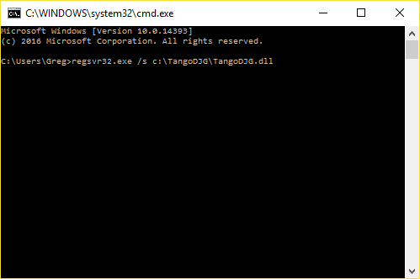

Windows Media Player Setup

Switching to Windows Media Player
If you were not previously using Windows Media Player and do not see your music in the WMP library, right click on the menu bar and select "File -> Manage Libraries -> Music"
From the pop window, you can add the location where you music is currently located.
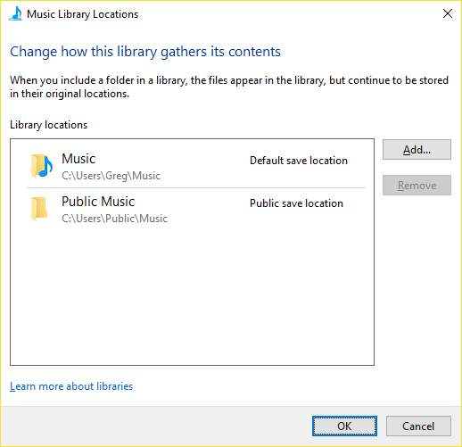

Display Columns
The plugin uses some column fields that may not be displayed by default. Right click on a column header such as "Title" and select "Choose Columns" From the popup, make sure the following are selected
- Title
- Subgenre
- Contributing Artist
- Release Year
- Mood

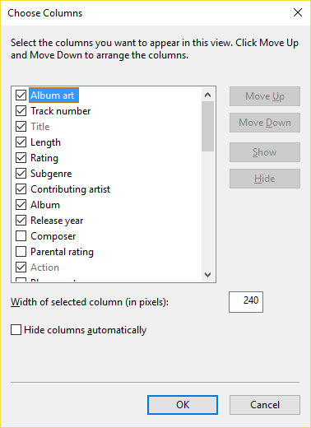

Plugin Configuration
First time users can skip this section for now until you get a feel of the different fields and whether or not you want to change default behavior or need to change something dynamically.
Unfortunately the last settings used are not saved. Each time you restart WMP, you will need to change the setting if you want something other than the default behavior.
In the WMP menu bar, right click and select "Tools -> Options". In the popup, select the "Plug-ins" tab, then under "Category:" select "Window".

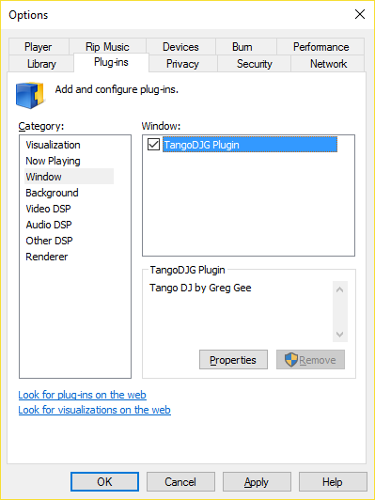

To the right under "Window:" select "TangoDJG Plugin" then click "Properties" and you get another popup. From here you can change default or dynamic behavior as described later in this document. When you click "Ok" parameters will be saved to "C:\ProgramData\TangoDJG\TangoDJG.cfg". Some parameters which only have a runtime impact will not be saved, they will be reinitialized the next time the plugin is started.

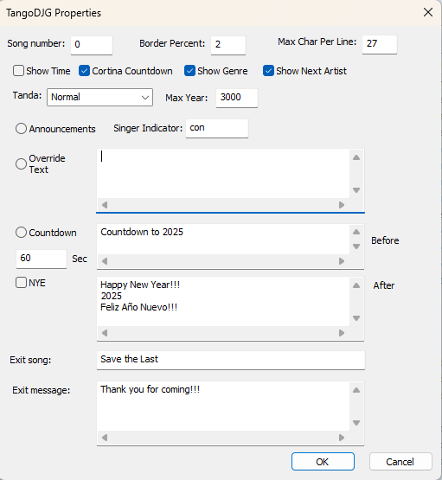

Starting the Plugin
After WMP is started, in the menu bar, right click and select "Tools -> Plug-ins -> TangoDJG Plugin" If you do not see "TangoDJG Plugin" as an option, the plugin was not installed correctly or may not be compatible. First try reinstalling the plugin. If it is shown, after selecting, you should see the plugin window open and display the date/version of the plugin
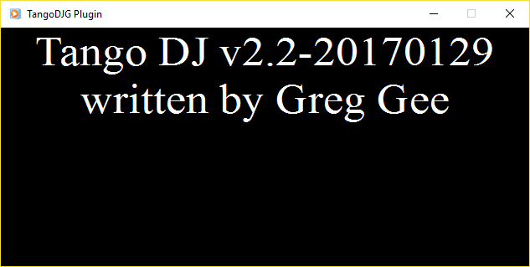
The window can be moved around on the desktop. I prefer to connect an external monitor, TV, or projector to the laptop, extend the display and move the plugin window to the extra display so I can adjust the music in WMP without everyone seeing it. This is a personal preference.

General Instructions For Music
The following instructions are related to music aspects of the plugin.
- The plugin is very dynamic. The window is generally updated with new information when a new song file is played. So you can change tandas on the fly with some limitations noted below.
- Songs with "BREAK" in the title are ignored. These can be used to add a few seconds of silence betweens songs so it does not immediately jump into the next song.
- If "CORTINA" is in the title, the song count is reset to zero so the next song indicates #1 in the tanda.
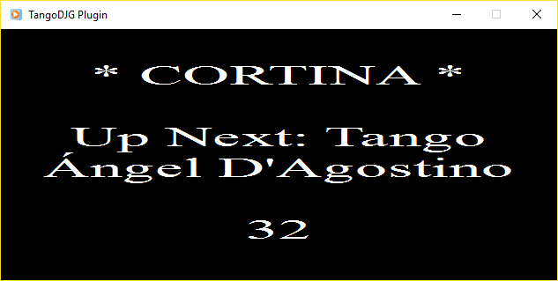
- During normal cortinas, the next song's 'Subgenre' and ' Contributing artist' will also be displayed unless disabled in the Plugin properties. Note your next tanda must be in place before the cortina file starts. Note if the tanda has multiple artists, only the artist for the first song after the cortina is displayed. It is too tricky to compare the artists up to the next cortina. For example Quinteto Pirincho is Canaro. So if "mix" is in the 'Mood' attribute (column), this is a hint to not display the next artist because it is a mix of artists. It is up to you to put this in if you change around your tandas.
- If you have long cortinas, as a dancer I've wondered how much longer is the cortina. If "Cortina Countdown" is checked in the plugin properties window, during the cortinas (except "CORTINA BYE"), a countdown is also displayed so the dancers know how much time is left in the cortina.
- If "CORTINA NEXT LAST" is in the title, the window indicates the next tanda will be the next to last one. A yellow border is drawn around the window for the next to last tanda.
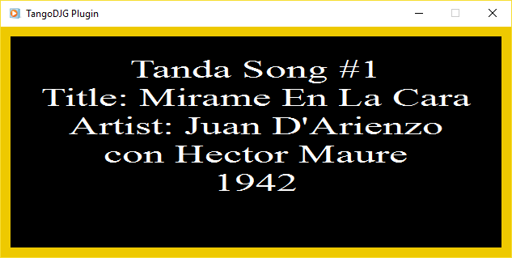
- If "CORTINA LAST" is in the title, the window indicates the next tanda will be the last one. A dark red border is drawn around the window for the last tanda and for each song it indicates "LAST" Tanda.
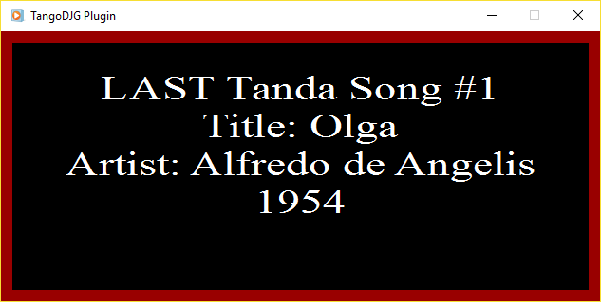
- The size of the border can be changed in the Plugin properties window with the Border Percent field. A value of zero will disable the border in which case the last two tandas will have no color differentiation from a regular tanda.
- If you are within the last two tandas and then decide to extend the milonga longer, in the Plugin properties window you can change the Tanda State with the selector and the window will be updated.
- If "BYE" is in the 'Mood' attribute, the window displays the exit message which by default says "Thank you for coming!!!". This can be changed in the Plugin properties window anytime the Plugin is open. An exit song title can also be configured in the Plugin properties, this title will also cause the exit message to be displayed. The Mood option was added as an easier method.
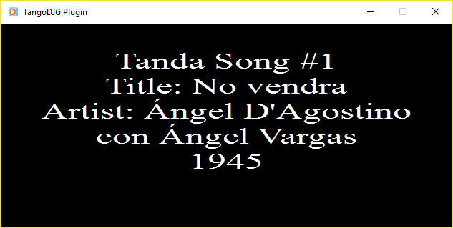
- The font dimensions are chosen based on the number of characters in the text and the size of the window. The dimensions will resize if the window is resized.
- If the 'Contributing artist' of a song is blank, the window will indicate "Unknown".
- The 'Contributing artist' can specify the singer; the format is '<orchestra> con <singer>'. If the plugin sees 'con' in the 'Contributing artist', the <singer> is put on a separate line for better formatting.
- If for some reason the song number indicated in the window is incorrect, it can be changed in the plugin properties window. Once you click ok, the window will be updated.
- If the song's 'Release year' has a value less than a 'Max Year', it is also displayed. This gives some control of whether or not to display the year. Some downloaded songs have the year it was re-released, not the original year. If your library doesn't have the correct years, you can lower the value 'Max Year' in the Plugin properties window. WMP may not like entering a blank value so if you don't want the year displayed for one particular song, you will need to set it to a large value above 'Max Year'.

Instructions for Extra Features
The following instructions are for extra features of the plugin.
- In the Plugin properties window, Override Text can be used to override what is displayed. If there is a performance or demo, this could be used to display their names. The text can be entered ahead of time with Override not checked. When ready, check Override and click 'Ok', then the display will change.
- If during the milonga you wish to pause for announcements, in the Plugin properties window, check "Announcements" and when you click 'Ok', "* Announcements *" will be displayed. The song count is set to zero so you can start a new tanda when ready.
- In the Plugin properties window, if "Show Time" is checked, the time is also displayed during normal cortinas.
- In the Plugin properties window, you can configure a generic "Countdown" and specify the number of seconds. During the countdown, the "Before" message is displayed and when it reaches zero, the "After" message is displayed.
- In the Plugin properties window, if "NYE" is selected, a countdown to the New Year is displayed. The plugin automatically calculates the number of Days, Hours, Minutes, and Seconds to the New Year and displays it. During the countdown, the "Before" message is displayed and when it reaches zero, the "After" message is displayed. The pluging will figure out what the new year is and fill it in as the default "After" message.
- If there is a performance, the names can be indicated in the Mood field. For example, if the Mood field for the song is "mix SHOW:Homer and Cristina", the text after "SHOW:" will be displayed.
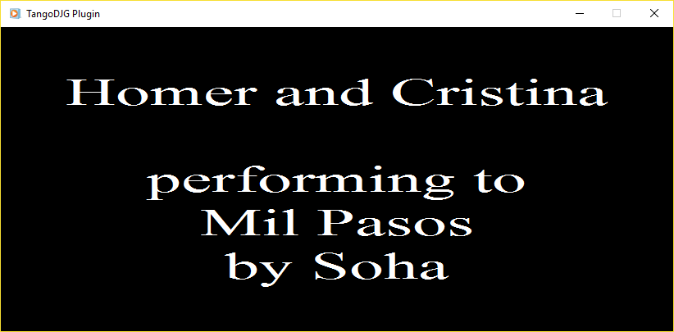

Media Monkey

Plug Installation
Inside the zip file there should be a TangoDJG.mmip file in addition to this manual.
Start Media Monkey.
Under the "Tools" menu, click "Options".
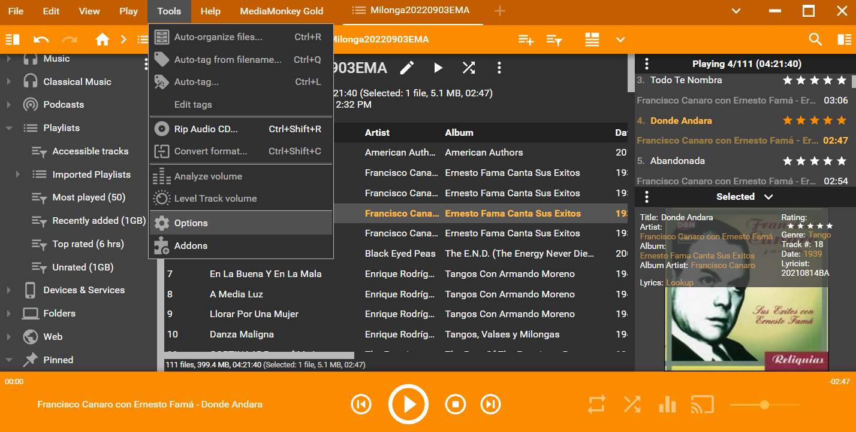
In the left menu, scroll down, then click "Addons"
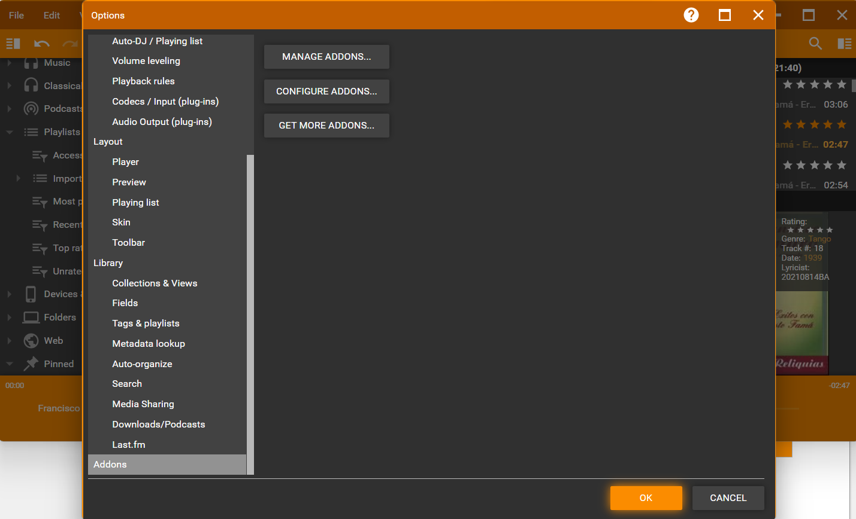
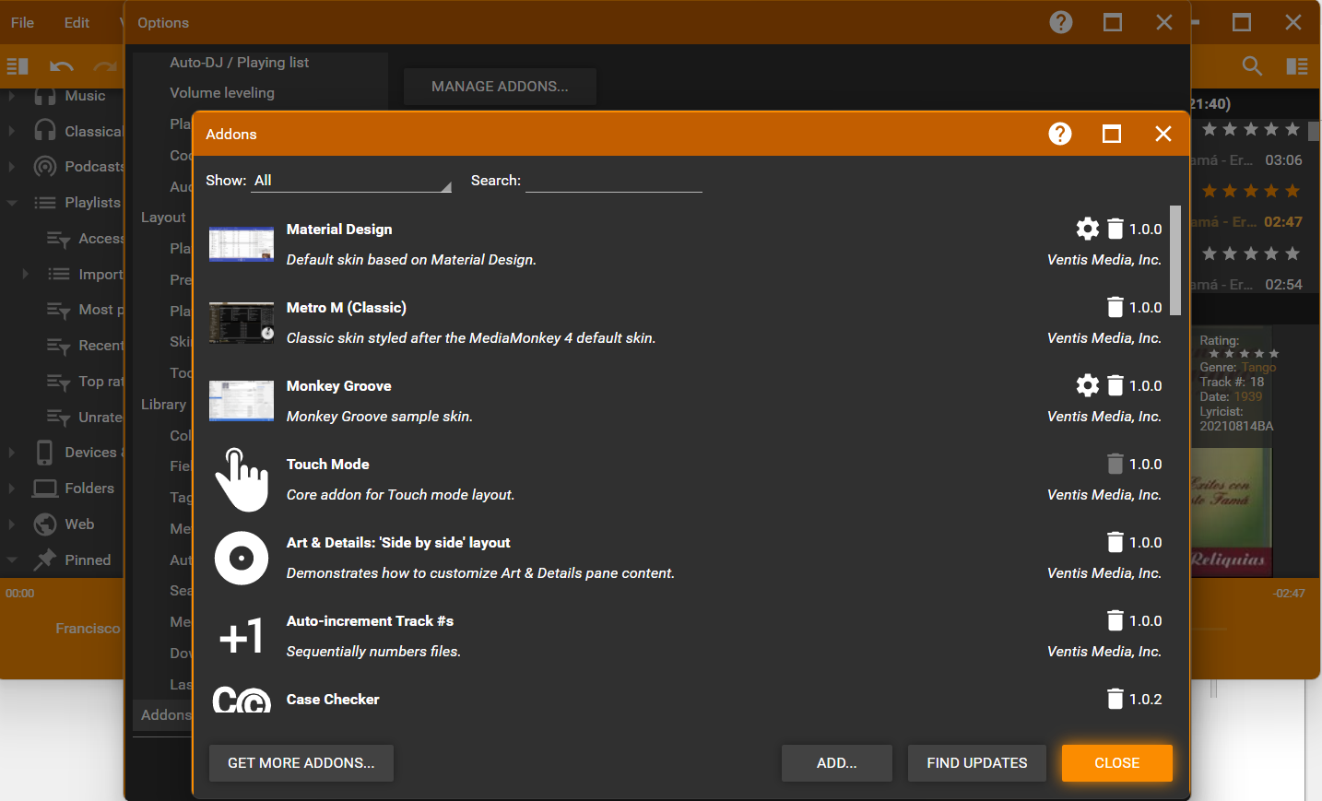
Click button "Manage Addons..."

Click button "ADD..."
Then browse, locate and select the file TangoDJG.mmip
Click button "OPEN"
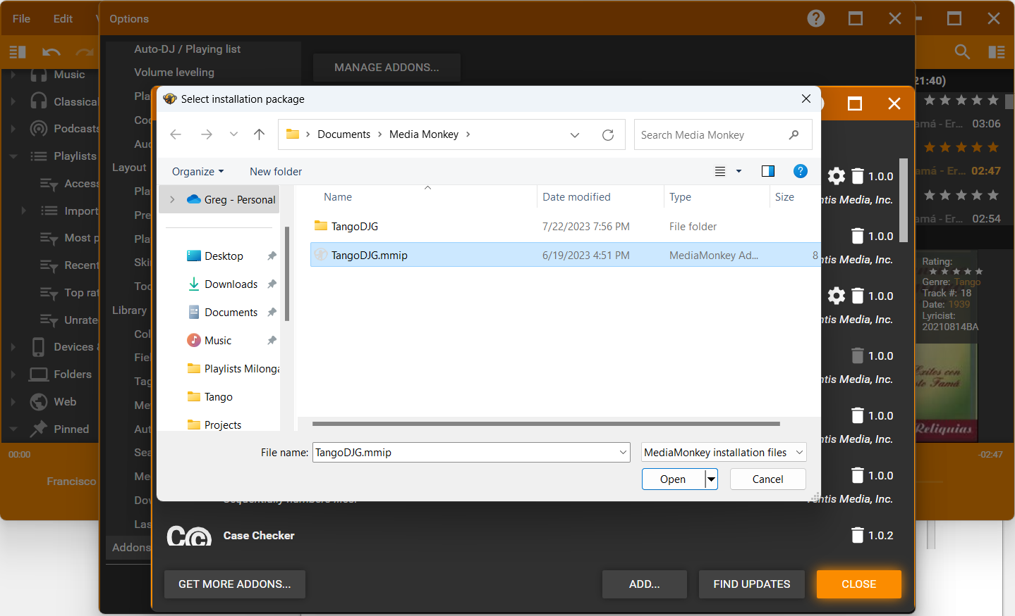

Click checkbox to accept the license terms, then click button "INSTALL NOW"
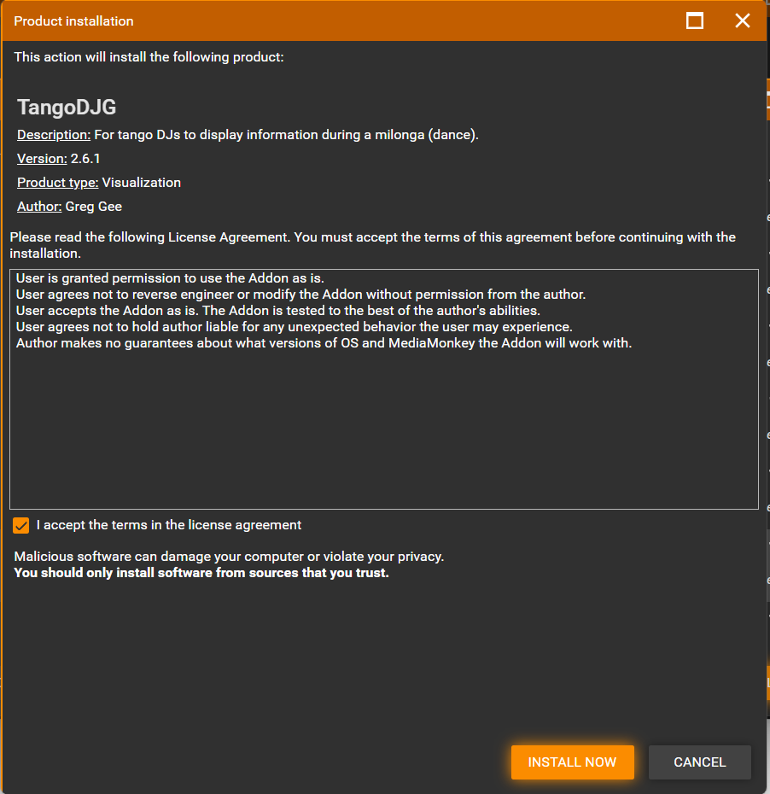

The initial configuration screen will be shown.
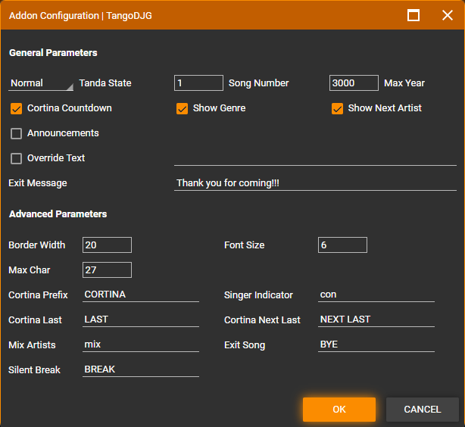
To complete the installation Media Monkey will ask to restart itself.
The Tools menu should now show an option for TangoDJG which will start the plugin.
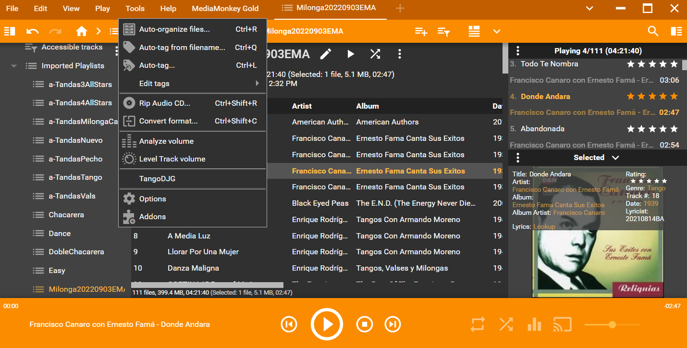

Display Columns
The plugin uses some column fields that may not be displayed by default. Right click on a column header such as "Title". From the popup, make sure the following are selected
- Title
- Grouping
- Artist
- Date
- Mood
Column "Date" indicates the release year.
Column "Grouping" is used for the SubGenre (e.g. Tango, Vals, Milonga, Alternative, Nuevo, etc)

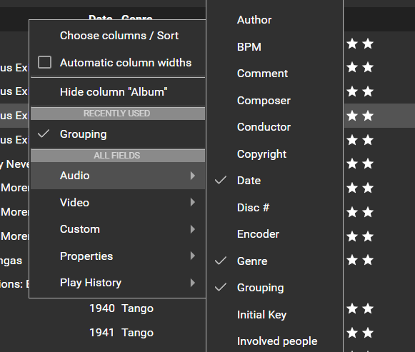

Column "Mood" is used for special instructions that are described later in the documentation.
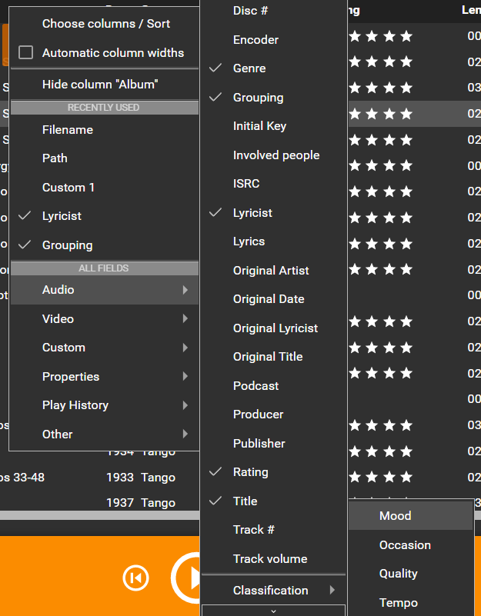

Plugin Configuration
The configuration screen can be accessed anytime from the Tools / Options / AddOns / Manage Addons screen. Click on the gear icon on the TangoDJG row.

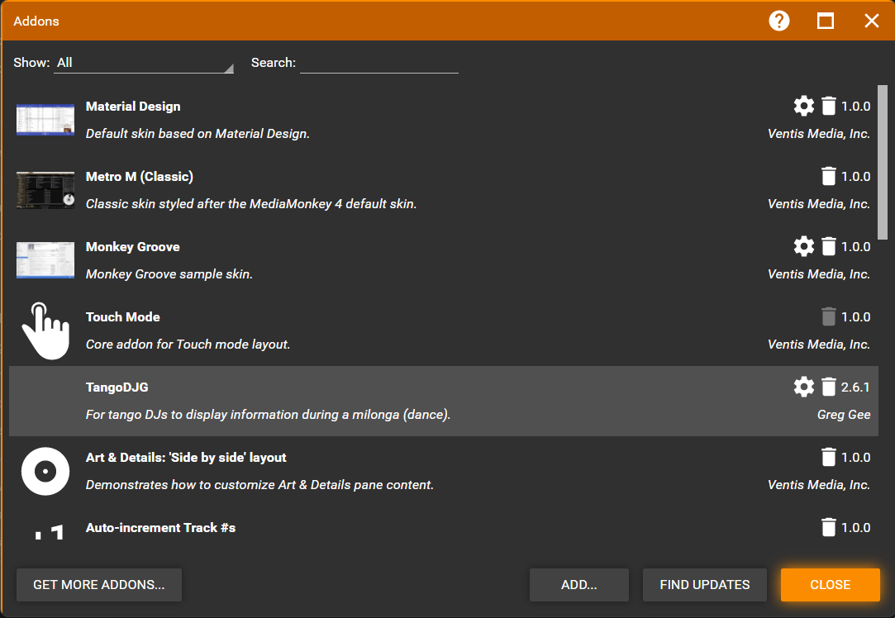

Starting the Plugin
When you start the plugin, an extra window will appear. For some reason when the window is small, the border is not drawn around the complete window. However when you enlarge, typically maximize the window, it should be drawn all the way around. The border is mainly used for the last 2 tandas.
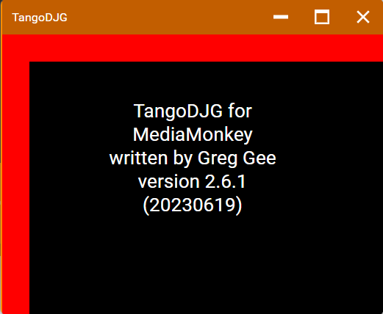

The window can be moved around on the desktop. I prefer to connect an external monitor, TV, or projector to the laptop, extend the display and move the plugin window to the extra display so I can adjust the music in Media Monkey without everyone seeing it. This is a personal preference.

General Instructions For Music
The following instructions are related to music aspects of the plugin.
- The plugin is very dynamic. The window is generally updated with new information when a new song file is played. So you can change tandas on the fly with some limitations noted below.
- Songs with "BREAK" in the title are ignored. These can be used to add a few seconds of silence betweens songs so it does not immediately jump into the next song. This text tag can be changed in the configuration with the "Silent Break" field.
- If "CORTINA" is in the title, the song count is reset to zero so the next song indicates #1 in the tanda. This text tag can be changed in the configuration with the "Cortina Prefix" field.

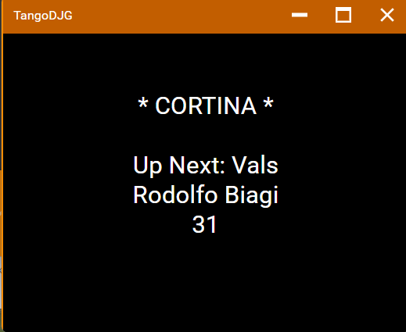

- During normal cortinas, the next song's 'Grouping' and 'Artist' will also be displayed unless disabled in the Plugin properties. Note your next tanda must be in place before the cortina file starts. Note if the tanda has multiple artists, only the artist for the first song after the cortina is displayed. It is too tricky to compare the artists up to the next cortina. For example Quinteto Pirincho is Canaro. So if "mix" is in the 'Mood' attribute (column), this is a hint to not display the next artist because it is a mix of artists. It is up to you to put this in if you change around your tandas. This text tag can be changed in the configuration with the "Mix Artists" field.
- If you have long cortinas, as a dancer I've wondered how much longer is the cortina. If "Cortina Countdown" is checked in the plugin properties window, during the cortinas, a countdown is also displayed so the dancers know how much time is left in the cortina.
- If "CORTINA NEXT LAST" is in the title, the window indicates the next tanda will be the next to last one. A yellow border is drawn around the window for the next to last tanda. This text tag can be changed in the configuration with the "Cortina Next Last" field.

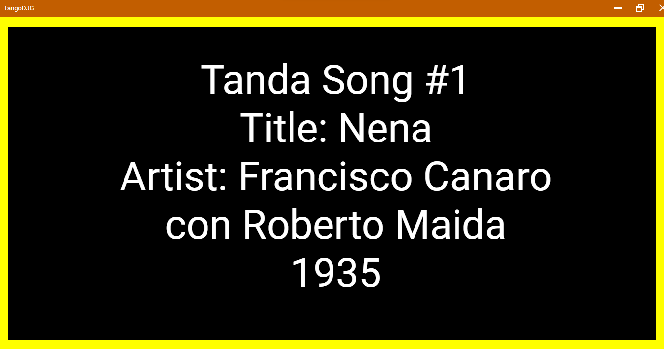
- If "CORTINA LAST" is in the title, the window indicates the next tanda will be the last one. A dark red border is drawn around the window for the last tanda and for each song it indicates "LAST" Tanda. This text tag can be changed in the configuration with the "Cortina Last" field.

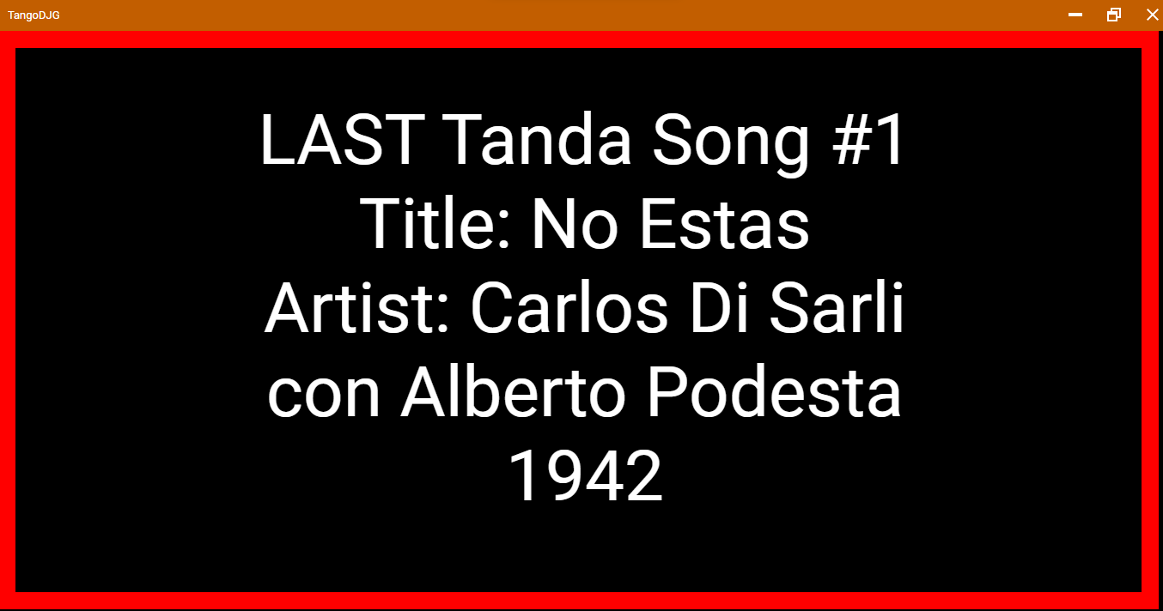
- The size of the border can be changed in the Plugin properties window with the "Border Width" field. A value of zero will disable the border in which case the last two tandas will have no color differentiation from a regular tanda.
- If you are within the last two tandas and then decide to extend the milonga longer, in the Plugin properties window you can change the "Tanda State" with the selector and the window will be updated.
- If "BYE" is in the 'Mood' attribute, the window displays the exit message which by default says "Thank you for coming!!!". This can be changed in the Plugin properties window anytime the Plugin is open. An exit song title can also be configured in the Plugin properties, this title will also cause the exit message to be displayed. The Mood option was added as an easier method.
- The font dimensions are chosen based on the number of characters in the text and the size of the window. The dimensions will resize if the window is resized. The relative size can be adjusted in the Plugin properties with the "Font Size" field but do so at your own risk.

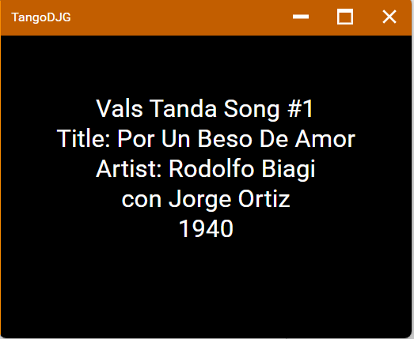

- If the 'Artist' of a song is blank, the window will indicate "Unknown".
- The 'Artist' can specify the singer; the format is '<orchestra> con <singer>'. If the plugin sees 'con' in the 'Contributing artist', the <singer> is put on a separate line for better formatting. The text tag can be changed in the Plugin properties with the "Singer Indicator" field.
- If for some reason the song number indicated in the window is incorrect, it can be changed in the plugin properties window. Once you click ok, the window will be updated.
- If the song's 'Date' has a value less than a 'Max Year', it is also displayed. This gives some control of whether or not to display the year. Some downloaded songs have the year it was re-released, not the original year. If your library doesn't have the correct years, you can lower the value 'Max Year' in the Plugin properties window.

Instructions for Extra Features
The following instructions are for extra features of the plugin. Note a few extra features from the original WMP plugin were deemed not worth porting over to the MM plugin.
- In the Plugin properties window, Override Text can be used to override what is displayed. If there is a performance or demo, this could be used to display their names. The text can be entered ahead of time with Override not checked. When ready, check Override and click 'Ok', then the display will change.
- If during the milonga you wish to pause for announcements, in the Plugin properties window, check "Announcements" and when you click 'Ok', "* Announcements *" will be displayed. The song count is set to zero so you can start a new tanda when ready.

